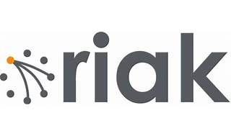

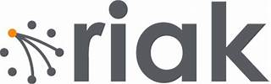

Explore

[**Riak** is a distributed **NoSQL key-value data store** that offers high availability, fault tolerance, operational simplicity, and scalability1](https://en.wikipedia.org/wiki/Riak). It’s commonly used for managing large volumes of unstructured or semi-structured data.

Here are **five free resources** where you can learn more about Riak and related topics:

1. [**Riak TS Getting Started Guide**](https://riak.com/resources/index.html): This guide walks you through your first project with Riak TS, which is optimized for IoT and time series data[2](https://riak.com/resources/index.html).
2. [**Riak TS Technical Overview**](https://riak.com/resources/index.html): Learn about Riak TS’s capabilities and how it compares to other NoSQL databases, especially for time series data[2](https://riak.com/resources/index.html).
3. [**Riak KV Enterprise Technical Overview**](https://riak.com/resources/index.html): Explore the features of Riak KV Enterprise, a highly resilient NoSQL database[2](https://riak.com/resources/index.html).
4. [**Pluralsight’s Riak Fundamentals Course**](https://www.pluralsight.com/courses/riak-introduction): Dive into the academic concepts behind distributed databases, with examples using Riak[3](https://www.pluralsight.com/courses/riak-introduction).
5. [**NIST’s Free Online Cybersecurity Learning Content**](https://www.nist.gov/itl/applied-cybersecurity/nice/resources/online-learning-content): While not specific to Riak, this resource covers coding, cybersecurity skills, and general IT knowledge[4](https://www.nist.gov/itl/applied-cybersecurity/nice/resources/online-learning-content).

Feel free to explore these materials to enhance your understanding of Riak and related technologies! 🚀